**INTERNSHIP PROJECT**

**ON**

**Snake Master Game**

**BACHELOR OF TECHNOLOGY**

**(COMPUTER SCIENCE & ENGINEERING)**

**SUBMITTED BY:**

**Nisha Kumari (19024010166)**

**UNDER THE GUIDANCE OF:**

**Mrs. Bhanu Priya**

**IN**



**DEPARTMENT OF COMPUTER SCIENCE AND ENGINEERING**

**ROORKEE INSTITUTE OF TECHNOLOGY**

**ROORKEE, UTTRAKHAND, INDIA**

**(2021-2022)**

**CERTIFICATE**

I hereby certify that the work which is being presented in these entitled “**Snake Master Game**” in partial fulfilment of the requirement for the award of degree of Bachelor of Technology and submitted in Department of Computer Science of Roorkee Institute of Technology, Roorkee, is an authentic record of my own work carried out under the supervision of **Mrs Bhanu Priya.**

The matter presented in this report has not been submitted by me anywhere for the award of any other Degree of this or any other institute.

**NISHA KUMARI**

This is to clarify that the above statement made by the candidate is correct to the best of our knowledge.

**Date: 09 MAY 2022**

HOD Project IN charge

**(DR. DEEPAK ARYA) (Mrs. Bhanu Priya)**

***STUDENT INFORMATION***

* NAME: ***NISHA KUMARI***
* COURSE: ***BTECH***
* BRANCH: ***COMPUTER SCIENCE AND ENGINEERING***
* UNIVERSITY ROLL NUMBER: ***190240101066***
* YEAR: ***3rd YEAR (2019-23)***
* COLLEGE NAME: ***ROORKEE INSTITUTE OF TECHNOLOGY***
* PROJECT NAME: ***SNAKE MASTER GAME USING JAVA***
* SUBMITTED TO: ***Mrs. Bhanu Priya***

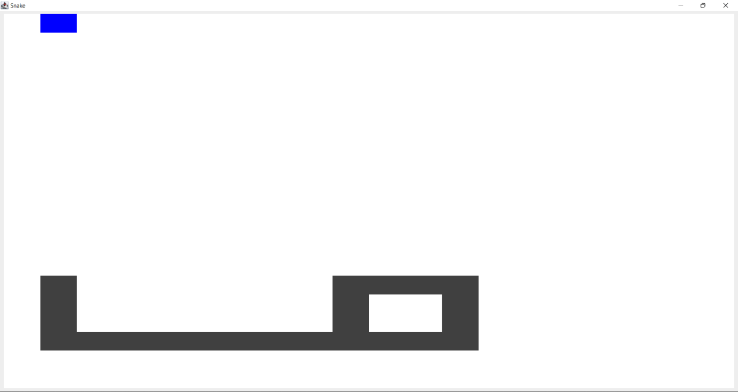

***ABOUT PROJECT:***

* Basically this is a snake master game (here written in JAVA language) which is designed in such a way that we have a food block and a snake in which the snake is made up of blocks and the food is also made up of block. The snake size increases whenever it eats the food block and this is the prime purpose of the game to move the snake in such a way that it doesn’t touch its own body otherwise the snake will die and the game will end.
* In this project, we use JAVA programming language because JAVA is currently being widely used in developing various games due to the vast pool of library it has, is cross-platform, easy to write, etc.
* Here, we used various JAVA components like:
  + AWT
  + Swing
  + Event handling
  + Array list
  + JFrame
  + Grid layout
* This is simple game which can be installed in televisions as well as in smart phones which small kids can play to increase their mind IQ.

***Mechanism involved in developing the Snake Master Game using JAVA–***

* Event handling of java
* Main Function
* Swing component of java
* Action Event functions of java
* AWT graphics of java
* JFrame component of java
* Grid layout concept of java

***LANGUAGES USED IN THE PROJECT***

In this project, Snake Master Game, JAVA programming language is used in both backend and at frontend. The main language used in both is JAVA in which swing, awt, event handling library, JFrame is also used at great extent.

***FUTURE SCOPE OF THE PROJECT***

1. This project is quite interesting and has a good future. This game is in market from almost 20 years but still the game holds strong position in market but this game has been made in JAVA programming language which makes this game quite light weighted, faster than before, better user interaction, and so on. This game can still be installed on various multimedia devices and televisions in order to give customers free game. This is very simple game and cheap too and can be easily be circulated in market.



1. The most eye-catching feature of this game is that it is non-addictive and can help small kids to increase their IQ which surely gives it a huge scope in market.

***SUMMARY***

Snake Master Game can be used widely because though it is a simple game but still it is highly beneficial for small kids as it will help in increasing their IQ. These games can be pre-installed on Television and Smartphones in order to give users free access to at least one game. We have used various libraries of Java in this project to make it user friendly and interesting for users.